FLORIDA NATIONAL SCENIC TRAIL
Apalachicola National Forest - West

Length = 46.4 MILES

FNST

Spur Trail

TH Trailhead

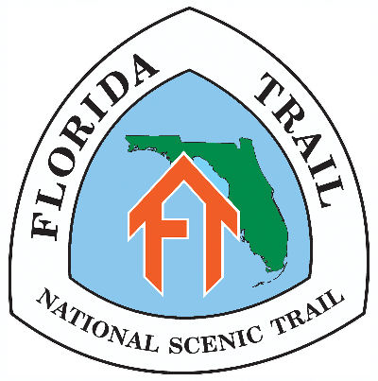

Highlights
The Apalachicola NF is one of the most remote sections on the Florida Trail; the forest is laced with dirt roads, but there are no towns or services for 77 miles. The 46-mile western section of the Forest starts at Porter Lake on the west bank of the Ochlocknee River and ends at the Apalachicola River. The trail passes through large of areas of pine flatwoods separated by titi and cypress swamps. The ghost town of Vilas, once a thriving turpentine community, has little left but hidden remnants of building foundations. Near Camel Lake, there are savannas of pitcher plants with lemon and cherry-red blooms in spring.

Mileage Points, east-to-west:
00.0 Porter Lake CG and TH on S. side of FH 13 [no sign at road]. Water, parking, restroom, one picnic table.
00.7 Cross FH 13.
03.0 Briefly join FR 142 to cross Hickory Branch.
04.2 Cross Coxes Branch.
04.4 Indian Creek. Camping in clearing on south side of trail just east of CR 67.
04.6 Cross Indian Creek on CR 67 bridge.
05.9 Cross FR 177.
06.8 Jct FR 107. Follow FR 107 west for 2.2 mi.
09.0 Trail enters woods on south side of FR 107.
10.2 Cross FR 175. Camping just beyond, in small clearing down path on north side of trail
14.2 Cross FR 107-B.
16.9 Turn west at jct of FR 107 and woods road. Follow FR 107 for 0.6 miles.
17.5 Jct with FR 107-A and FR 126.
18.9 Vilas camping area. No water.
19.0 Jct with FR 120. TH, parking. Turn west on FR 120 and cross railroad tracks.
19.3 Turn south at jct FR 120 and SR 65.
19.4 Cross New River on SR 65 bridge.
19.6 Turn west at jct of SR 65 and FR 112.
19.7 Jct with FR 112 at cattle-proof fence crossing. Follow woods road.
22.4 Cross Hostage Creek on FR 112-H.
23.9 Cross 2,622-foot puncheon. Pitcher plants.
25.5 Jct FR 108 / FR 108-E.
25.9 South jct with 4-mile blue-blazed Trail of Lakes. Bonnet Pond to north.
27.5 Trail crosses Big Gully Creek on FR 105.
29.4 Cross FR 105. Jct 0.3-mile blue-blazed trail to Camel Lake CG.
31.4 At Memery Island, north jct with 4-mile blue-blazed Trail of Lakes.
33.8 Cross Little Gully Creek on FR 150. Trail through pine savanna with profuse pitcher plants.
34.8 300-ft. spur trail to Savannah Trailhead on FR 150.
34.9 Jct with CR 12. Follow highway north to Bristol.
45.9 Jct CR 12 and SR 20 in Bristol. Follow SR 20 west.
46.4 FNST crosses Apalachicola River on highway bridge. ET/CT time zone change.

Trailhead directions:
Directions to Porter Lake, Vilas and Savannah trailheads can be found on our Apalachee Chapter website at
http://apalachee.floridatrail.org/big-bend-area-trails/apalachicola-natl-forest-west/ .
Click on “Click here for trail-heads map and directions” at the bottom of the page. All parking at your own risk.

Conveniences:
Supplies: Tallahassee, Hosford, Bristol.
Lodging: Tallahassee; Bristol: Snowbird Motel, (850) 643-2330.
Public Campgrounds: Porter Lake, Whitehead Lake, Wood Lake and Camel Lake -- all in the National Forest.

Emergency Numbers:
Apalachicola District USFS (Bristol): 850-643-2282. Liberty County Sheriff: 850-643-2235. FHP: 850-245-7700.

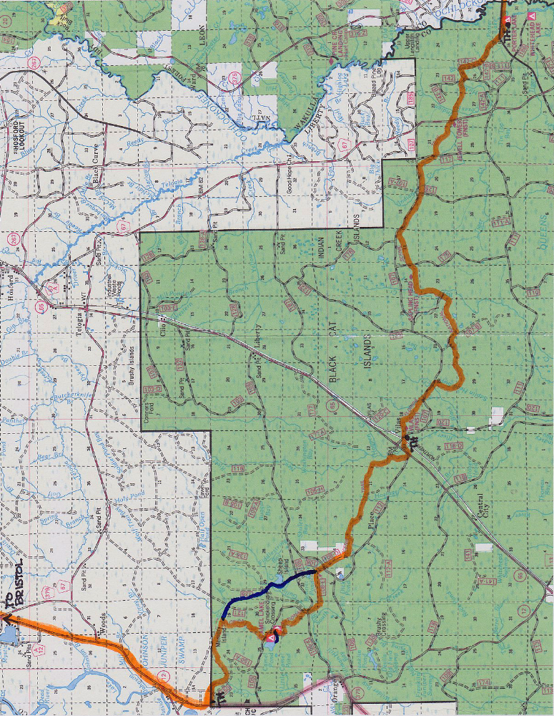

To purchase detailed FTA maps
and data book,
visit www.floridatrail.org and click on “Shop”...

then ‘Maps,’ then ‘FTA Maps,’ then ‘Printed Maps’
[select map “9/10 Apalachicola”...]
[...and select map “11/12 St. Marks/Aucilla...”]

...and then “Publications,” and then “Florida Trail”
[select “2014-2015 Florida Trail Data Book”]
[Also select “The Florida Trail Guide” for trail details
and town information/maps.]

Prepared by Linda Patton - July 2011, rev. 1/20/15

